SIMATS ENGINEERING

ASSESSMENT TOOL 1

COURSE NAME: Artificial Intelligence COURSE CODE: CSA1708

COURSE OUTCOME COVERED
CO5: Design AI-based systems using PySpark, RDD operations, and intelligent agent architectures, using scalable systems and integrate components in distributed AI applications. (BTL 5)
Assessment Tool Weightage: 50%

Duration : 1 Hour
QUESTIONS: 5 Total Marks:50
Annexure A

Design Task

Code of Conduct:
I Soundariya M (192524342) (Name / Reg No) certify that this submission is my original work and that I have adhered to the guidelines specified for this assessment.
I understand that any violation of academic integrity rules will result in disciplinary action.

Signature of the student:
Soundariya M

Annexure A

Design Task
- Hybrid AI Recommendation Engine Design
Design a hybrid AI-based recommendation system that integrates content-based and collaborative filtering techniques using PySpark RDDs. Explain how distributed data processing can be used to handle large-scale user-item interactions, and describe the role of intelligent agents in adapting recommendations based on user behavior and feedback in real time.

- Smart Disaster Detection System
Develop a distributed AI system using PySpark and RDD operations to detect natural disasters (such as floods or earthquakes) from multi-source data streams (satellite images, sensors, and social media). Describe the system architecture, data fusion techniques, and how intelligent agents coordinate to provide early warnings and response strategies.

- AI-Based Fraud Detection Framework
Design a scalable fraud detection system using PySpark RDDs to process large volumes of financial transactions. Explain how anomaly detection algorithms can be implemented in a distributed manner and how intelligent agents collaborate to identify suspicious patterns, trigger alerts, and continuously improve detection accuracy.

- Autonomous Supply Chain Optimization System
Construct a distributed AI system using PySpark for optimizing supply chain operations (inventory, logistics, demand forecasting). Describe how RDD transformations support large-scale data processing and how multiple intelligent agents interact to make decentralized decisions for cost minimization and efficiency improvement.

- Personalized Learning Analytics Platform
Design an AI-driven educational platform that uses PySpark and RDDs to analyze student learning behavior and performance data. Explain how the system supports adaptive learning through intelligent agents, real-time feedback, and scalable analytics to personalize content delivery for thousands of learners.

RUBRICS FOR CALCULATION

Evaluation Criteria | Problem Underst anding & Require ment Analysis | System Architect ure Design | Use of PySpark & RDD  Operatio ns | Intelligen t Agent Integrati on | Scalabilit y & Distribut ed Computin g Design | Data Flow & Processin g Pipeline | Innovatio n & Creativity | Clarity, Presentati on & Document ation
Weightage | 10% | 20% | 15% | 15% | 10% | 10% | 10% | 10%

Criteria | Excellent (5) | Good (4) | Average (3) | Poor (2)
Problem Understanding & Requirement Analysis | Clearly defines problem, objectives, and constraints | Mostly clear with minor gaps | Basic understanding | Unclear or incorrect
System Architecture Design | Complete, scalable,  well-structured architecture with diagrams | Good design with minor issues | Basic design, lacks detail | Poor/incomplete
Use of PySpark & RDD Operations | Efficient and correct use of RDD  transformation s/actions | Mostly correct usage | Limited or partial use | Incorrect/missing
Intelligent Agent Integration | Strong integration with clear agent roles and logic | Good integration | Basic integration | Poor/no integration
Scalability & Distributed Computing Design | Clearly addresses scalability, fault tolerance, parallelism | Covers most aspects | Limited consideration | Not addressed
Data Flow & Processing Pipeline | Clear, logical, and  well-defined data flow | Mostly clear | Some gaps | Poorly defined

Innovation & Creativity | Highly innovative, realistic, and impactful solution | Some innovation | Basic idea | No originality
Clarity, Presentation & Documentation | Very clear, neat diagrams,  well-organized report | Mostly clear | Somewhat organized | Poor presentation

Design Task – Distributed AI Systems Using PySpark RDDs
- Hybrid AI Recommendation Engine Design

Objective
To design a scalable recommendation system that combines content-based filtering and collaborative filtering using PySpark RDDs.

Architecture
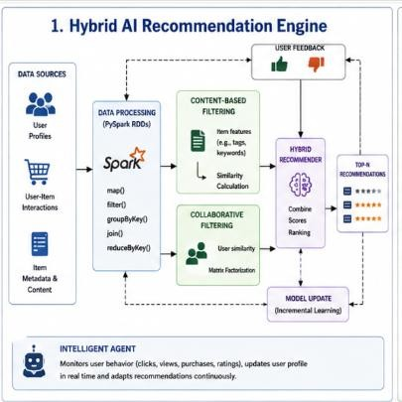

PySpark RDD Processing
RDDs can distribute large user-item datasets across multiple worker nodes. Typical operations include:
  - map() – extract user, item, rating, and feature information.
  - filter() – remove invalid interactions.
  - groupByKey() – group interactions by user or item.
  - reduceByKey() – calculate aggregated ratings or interaction counts.
  - join() – combine user and item information.

Recommendation Techniques

Content-Based Filtering:
Recommends items similar to those previously viewed or purchased by the user based on item features.

Collaborative Filtering:
Finds users with similar behavior and recommends items they liked.

Hybrid Approach:
Combines both scores to produce a more accurate recommendation.

Intelligent Agents
A recommendation agent observes:
  - Clicks
  - Searches
  - Purchases
  - Ratings
  - Time spent on items
It updates the user's preference profile and adjusts recommendations based on new feedback.

Conclusion
The hybrid approach improves recommendation quality by combining item similarity and user behavior, while PySpark enables the system to process millions of interactions in parallel.

Smart Disaster Detection System
Objective
To develop a distributed AI system that detects floods, earthquakes, and other disasters using satellite data, sensors, and social-media information.

Architecture
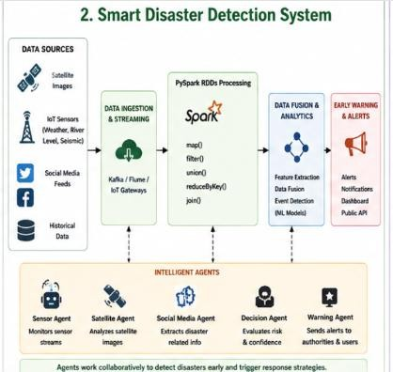

Data Fusion
Different sources are combined to improve detection reliability. For example:
  - Sensor data detects rising water levels.
  - Satellite images identify flooded areas.
  - Social-media posts provide information about affected locations.
The system compares these sources and generates a disaster confidence score.

PySpark RDD Operations
  - map() – extract useful information from each data source.
  - filter() – remove invalid or irrelevant records.
  - union() – combine datasets from multiple sources.
  - reduceByKey() – aggregate information by location.
  - join() – combine sensor and geographical information.

Intelligent Agents
Different agents can perform specialized tasks:
  - Sensor Agent: Monitors sensor readings.
  - Satellite Agent: Analyzes satellite information.
  - Social Media Agent: Detects disaster-related information.
  - Decision Agent: Combines evidence and evaluates risk.
  - Warning Agent: Sends alerts to authorities and affected users.

Conclusion
Distributed processing allows huge amounts of disaster-related data to be analyzed quickly. Multi-source data fusion improves detection accuracy, while intelligent agents coordinate detection and warning activities.

AI-Based Fraud Detection Framework

Objective
To design a scalable system that detects suspicious financial transactions using PySpark RDDs and anomaly detection.

Architecture
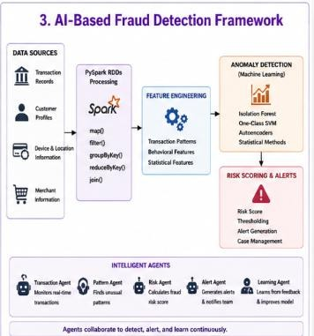

Distributed Processing
RDDs divide transactions across multiple worker nodes. Operations:
  - map() – extract transaction features.
  - filter() – remove invalid transactions.
  - groupByKey() – group transactions by customer/account.
  - reduceByKey() – calculate transaction frequency or amount.
  - join() – combine transaction and customer information.

Anomaly Detection
The system can identify unusual:
  - Transaction amounts.
  - Transaction frequency.
  - Locations.
  - Device usage.
  - Time patterns.
An anomaly score can be calculated for every transaction. Transactions with high scores are sent for further investigation.

Intelligent Agents
  - Transaction Agent: Monitors incoming transactions.
  - Pattern Agent: Searches for unusual behavior.

  - Risk Agent: Calculates fraud risk.
  - Alert Agent: Generates alerts.
  - Learning Agent: Uses confirmed fraud/non-fraud feedback to improve future detection.

Conclusion
PySpark enables high-volume transaction processing, while distributed anomaly detection identifies suspicious behavior. Intelligent agents provide continuous monitoring and feedback-based improvement.

Autonomous Supply Chain Optimization System

Objective
To design a distributed AI system for inventory management, logistics optimization, and demand forecasting.

Architecture
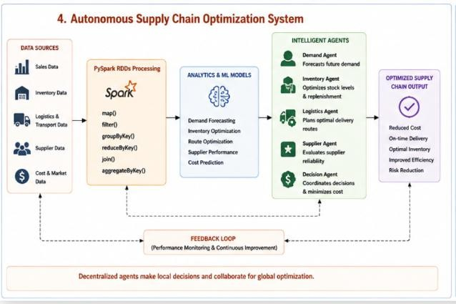

RDD Transformations
  - map() – convert raw records into useful key-value pairs.
  - filter() – remove incorrect or unnecessary records.
  - groupByKey() – group sales by product/location.
  - reduceByKey() – calculate total sales and inventory.
  - join() – combine inventory, sales, and transportation data.

Intelligent Agents

Demand Agent: Forecasts future product demand.
Inventory Agent: Determines when and how much stock should be replenished.
Logistics Agent: Selects efficient transportation routes.
Supplier Agent: Monitors supplier performance and availability.
Decision Agent: Coordinates the agents and selects actions based on cost, demand, and delivery requirements.

Optimization Goals
  - Reduce inventory costs.
  - Minimize transportation costs.
  - Avoid stock-outs.
  - Improve delivery time.
  - Balance supply and demand.

Conclusion
PySpark provides scalable processing of supply-chain data, while multiple intelligent agents make decentralized decisions and coordinate with one another to improve overall efficiency.

Personalized Learning Analytics Platform
Objective
To design an AI-based educational platform that analyzes learning behavior and provides personalized content and real-time feedback to thousands of students.

Architecture
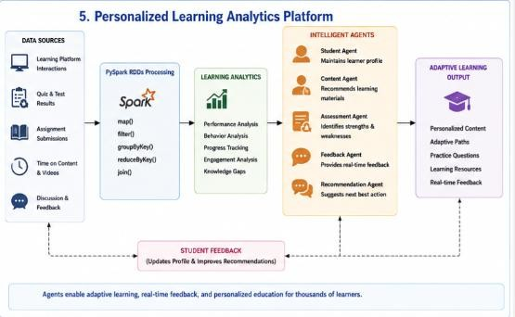

RDD Processing
RDDs can process learning records distributed across many nodes. Examples:

  - map() – extract student performance features.
  - filter() – remove invalid records.
  - groupByKey() – group activities by student.
  - reduceByKey() – calculate average scores.
  - join() – combine performance with course/content information.

Intelligent Agents

Student Agent: Maintains an individual learning profile.
Content Agent: Selects suitable learning materials.
Assessment Agent: Identifies strengths and areas needing improvement. Feedback Agent: Provides immediate feedback after quizzes and activities. Recommendation Agent: Recommends the next lesson or practice activity.

Adaptive Learning
For example:
Low Quiz Score
↓
Agent detects weak topic
↓
Recommends easier explanation
↓
Provides practice questions
↓
Student attempts quiz
↓
Agent updates learning profile
The system continuously adapts content based on the learner's performance, progress, and interaction history.

Conclusion
PySpark enables scalable analysis of learning data from thousands of students. Intelligent agents continuously monitor learning behavior and personalize content, recommendations, and feedback for each learner.

